## Introduction

ESC known as electronic speed controller is used to control the speed at which the brushless motor turns by supplying with varying pulse width modulation signals. The ESC sends AC signals to brushless motor at different frequency to control rotation.ESC also regulates the battery source down to the voltage needed by motors.

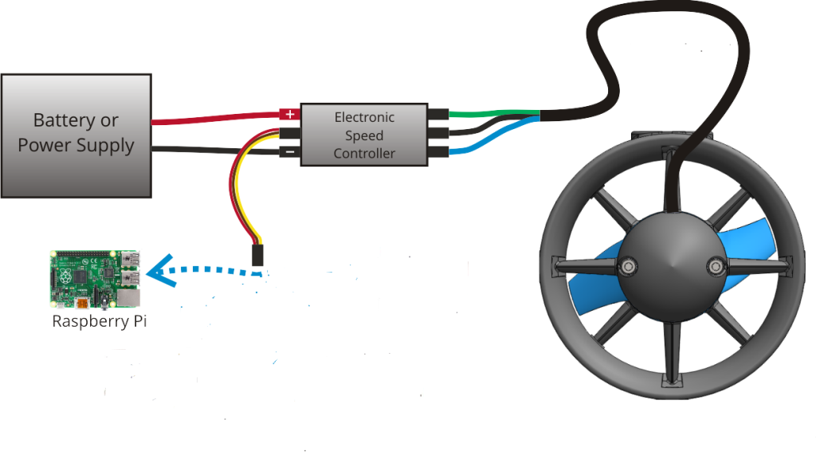

Figure 5.a: Wiring diagram of ESC

## Pulse width modulation

The input signal from raspberry pi to ESC is called pulse width modulation signals. The voltage levels of this signal vary in time between the common voltages, thought of as 0 volts, and 5 volts for our setup. The PWM signal consists of square pulses separated in time where the width of the pulse corresponds to the commanded position of brushless motors.  A short pulse would drive a motor to its minimum range and a long pulse to the maximum range.  When the PWM signal is fed into an ESC the short pulses would signify low throttle (or no throttle) and long pulse to high throttle. For brushless motors, we use low throttle to mean low RPMs and high throttle for high RPMs

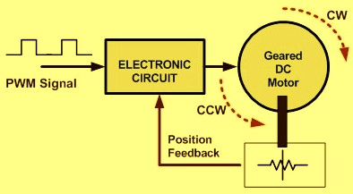

Figure 5.b: working principles of ESC

In the above figure 20 the position feedback is sent by the motors to ESC to notify the ESC its current position so that the ESC knows where to send the PWM next to make the motor rotate.

## Working principle of PWM

## pwm1.jpg

Figure 5.c: PWM principle

PWM is a technique used to relay data in the form of a varying pulse width. In figure 21 by varying the width we control the position of motor as well as the speed at which the motor is rotating. ESC calibration involves making sure the ESC can interpret from the signal the stop and maximum speed of the motors

## Mystery Fire dragon ESC Programming

The default signal range for most brushless motors and ESCs is a high signal width between 1000 and 2000 microseconds over a repetition period of 20 milliseconds (assuming a 50 Hz PWM signal).  For the Quad copter, however, we want the range to be as wide as possible to allow for greater incremental control of the motor.  To this end, we calibrated the ESCs to read a signal width from 700 to 2000 microseconds with 700 being the stop speed and 2000 being the max speed. We found that the ESC could not read a signal lower than 700 microseconds.

Calibrating the Mystery ESCs was quite simple.  To enter programming mode, the maximum servo signal (2000 microseconds) is sent to the ESC, the ESC is powered on and emits to beep. After hearing the beep twice send the minimum send the minimum servo signal 700 microseconds. Once the ESC emits a series of confirmation beeps (special wave signals sent to the motor to emit beeping sounds), the ESC is calibrated.